NOTICE OF PUBLIC HEARING
Centerton Board of Zoning Adjustment
July 5, 2022, at 6:00 PM

NOTICE IS HEREBY GIVEN that a public hearing will be held before the City of Centerton Board of Zoning Adjustment on July 5, at 6:00 PM at the Centerton Court Building to hear public comment and consider a petition submitted by property owners Kirk & Kelly Buttle for up to a 5-ft reduction in the required side building setback from 7-ft to 2-ft (VAR22-07) to construct a woodworking shop.
Property is described as Lot 169, 1050 Sawtooth Circle, Oak Tree Subdivision, City of Centerton, Benton County, AR, aka (PID 06-04502-000).
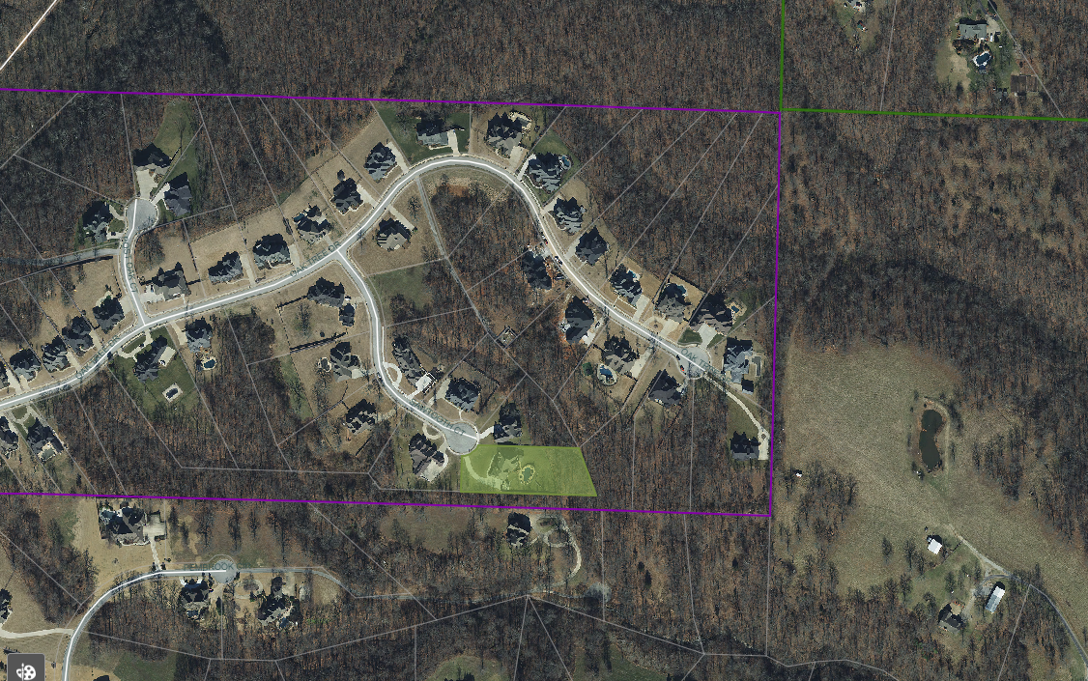
All interested are encouraged to attend the meeting. For questions or comments, contact Centerton Planning Department, PO Box 208, Centerton, AR 72719, planning@centertonar.us, (479) 795-2750 Ext.302. Additional information can be found at centerton.us/planning-and-zoning.
SHORT RD
PEMBROOK CIR
POST OAK DR
CENTERTON
PLANNING AREA
OAK TREE DR
CENTERTON
PLANNING AREA
SUBJECT
PROPERTY
Documents will be available prior to meetings for public review. Please email planning@centertonar.us to submit comments or request further information in advance of the meeting. Note that comments received the day of the meeting may not be added to the packet due to time restraints.
Bullock Rd

