NOTICE IS HEREBY GIVEN that a Public Hearing will be held before the City of Centerton, Arkansas Planning Commission on May 18, 2021 at 6:00 PM by virtual meeting to hear public comment on application for property located at W 2525 W Centerton Blvd, submitted by Chris Callis, property owner, to rezone 5.04± acres of the following described property from A-1, Agricultural to R-1, Low Density Residential (3.0 acres) and C-2, Highway Commercial (2.03 acres).
Property is described as part of the NE¼ of the NW¼ of S6-T19N-R31W in the City of Centerton, Benton County, AR; aka PID#06-00047-122.
All persons interested in this request are invited to participate by using the website link found at www.centertonar.us/planning-and-zoning, or to call, visit, or email the Planning Office at Centerton City Hall, 290 Main Street, (479) 795-2750, planning@centertonar.us.
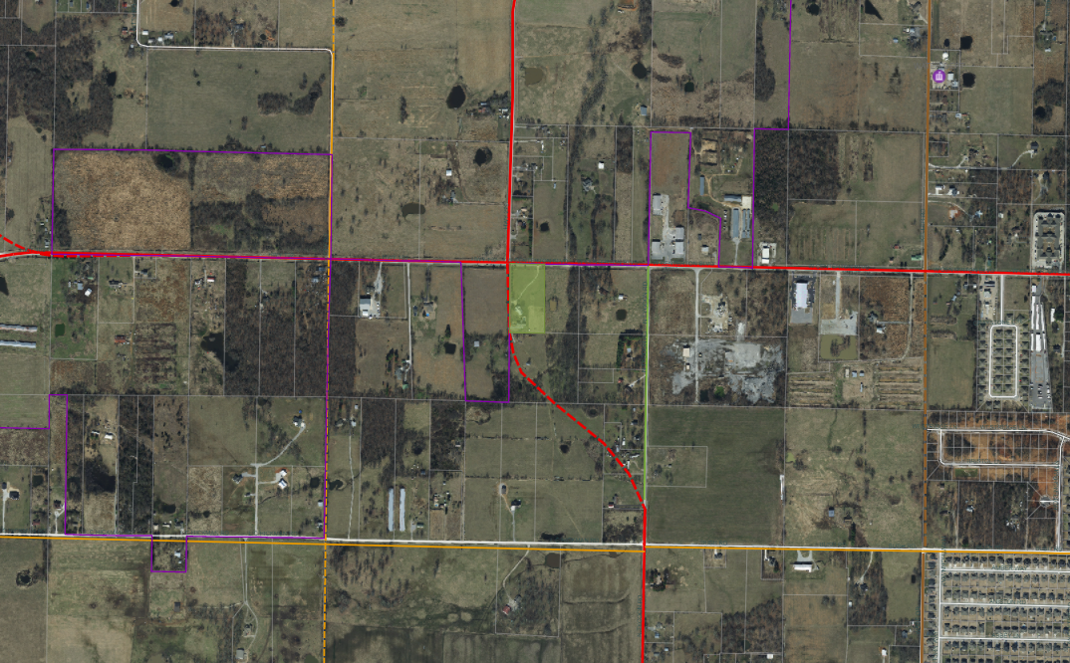
COVID-19 DISCLAIMER: The City remains committed to providing opportunities for the community to publicly comment on items being considered, and currently provides virtual meetings to support the recommended practice of social distancing. Documents will be available prior to meetings for public review. Please email planning@centertonar.us to submit comments or request further information in advance of the meeting. All Notice of Public Hearings, Meeting Agendas, and information as to how the public may join virtually, will also be posted in the City Hall lobby and on the City’s website at www.centertonar.us/planning-and-zoning.
TAMARRON SUBDIVISION
LC HICKMAN RD
N TYCOON RD
COUNTY
CENTERTON
COUNTY
CENTERTON
WATER DEPT
KELLER RD
PROPOSED MINOR ARTERIAL
BUSH RD
CENTERTON BLVD
CENTERTON BLVD
HWY 279
N TYCOON RD
LC HICKMAN RD
PROPOSED MAJOR ARTERIAL
CENTERTON
COUNTY
SUBJECT PROPERTY

