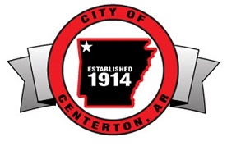

JOB OPPORTUNITY
The City of Centerton is accepting applications for a
PART TIME – Custodian position with City Hall.

Applicants must be at least 18 years of age. We are looking for a janitor, to take care of our building and carry out cleaning, maintenance duties. The goal is to keep our building in a clean and orderly condition.

To request a job description, application or any other information please contact Human Resources at careers@centertonar.us
or (479) 795-2750 ext. 104

Please pick up and submit your application at the following location:
City of Centerton City Hall
200 Municipal Drive
Centerton, Arkansas 72719

Applications accepted until positions filled

