NOTICE IS HEREBY GIVEN that a Public Hearing will be held before the City of Centerton, Arkansas Planning Commission on June 1, 2021 at 6:00 PM by virtual meeting to hear public comment on the application submitted by Morrison Shipley on behalf of property owner, Christian Life Center of Centerton/James King, Pastor, to develop 2.80 acres± (PID 06-00050-065) as a religious facility.
Property is described as part of the NE¼ of the NE¼ of S32-T20N-R31W, Centerton, Benton County, AR; aka PID#06-00050-065.
All persons interested in this request are invited to participate by using the website link found at www.centertonar.us/planning-and-zoning, or to call, visit, or email the Planning Office at Centerton City Hall, 290 Main Street, (479) 795-2750, planning@centertonar.us.

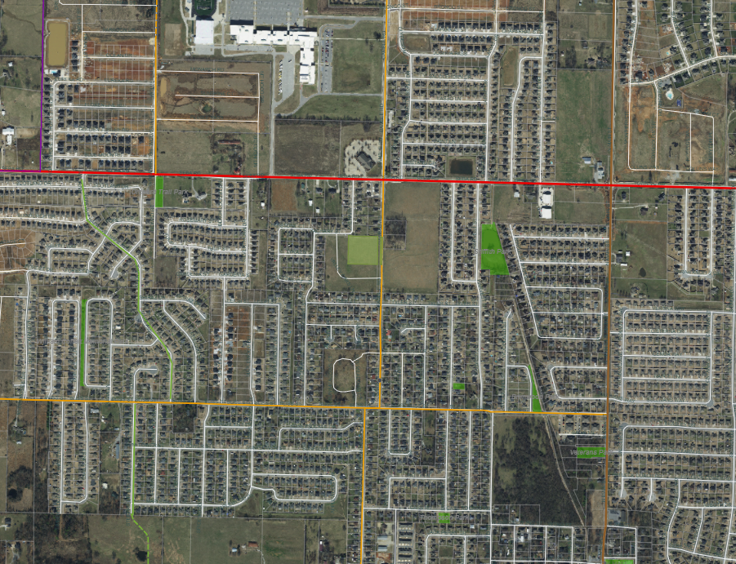
WILLIAM COFFELT MEMORIAL PARK
VETERAN’S PARK
WALKER STREET PARK
BWHS
BRIMWOOD PARK
ORCHARD TRAIL PARK
GRIFFITH
PARK
VALLEY OAKS
SUBJECT
PROPERTY
S MAIN ST
SUN MEADOWS DR
WOLVERINE DR
N STEEPRO DR
NAPA AVE
PLANNING AREA
CENTERTON
BLISS ST
GAMBLE RD
GAMBLE RD
N MAIN ST
S MAIN ST
TOWN VU RD
SEBA RD
SEBA RD
COVID-19 DISCLAIMER: The City remains committed to providing opportunities for the community to publicly comment on items being considered, and currently provides virtual meetings to support the recommended practice of social distancing. Documents will be available prior to meetings for public review. Please email planning@centertonar.us to submit comments or request further information in advance of the meeting. All Notice of Public Hearings, Meeting Agendas, and information as to how the public may join virtually, will also be posted in the City Hall lobby and on the City’s website at www.centertonar.us/planning-and-zoning.

