Notice is hereby given that a Public Hearing will be held before the Centerton Planning Commission on June 1, 2021 at 6:00 PM by virtual meeting to hear public comment on the application submitted by Steven Mitchael, for a Conditional Use request for the Temporary Use of a fireworks tent, within C-2, Highway Commercial on 5.42± acres located at
11507 W AR Hwy 72.
Property is described as part of the NW¼ of the NE¼ of S28-T20N-R31W, City of Centerton, Benton County, AR, PID# 06-00047-300.
All those interested in this request are invited to participate by using the website link found at www.centertonar.us/planning-and-zoning or to call, visit, or email the Planning Office at Centerton City Hall, 290 Main Street, (479) 795-2750 Ext 27, planning@centertonar.us. 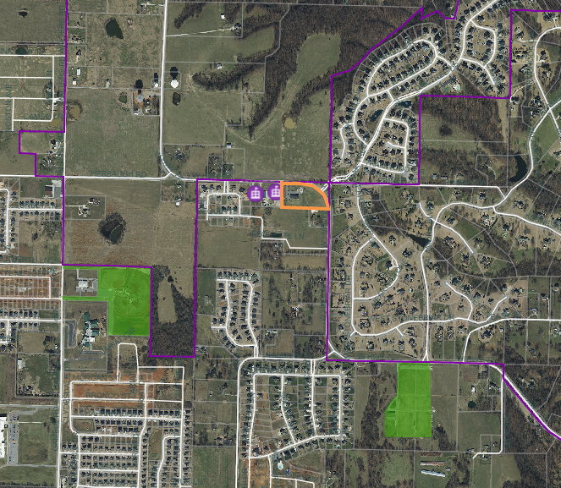
Oak Tree
Subdivision
Centerton
Streets Dept
Subject
Property
Gamble Rd
N Main St
Hwy 72
Hwy 72
Hwy 72
Walters Rd
Herbaugh Rd
Lightning
Soccer
Park
Tuscany
Subdivision
Bequette Farms
Subdivision
Centerton
Sports
Park
Gamble
Elementary
Forest Park
Subdivision
Lexington
Subdivision
Talamore Subdivision
COVID-19 DISCLAIMER: The City remains committed to providing opportunities for the community to publicly comment on items being considered, and currently provides virtual meetings to support the recommended practice of social distancing. Documents will be available prior to meetings for public review. Please email planning@centertonar.us to submit comments or request further information in advance of the meeting. All Notice of Public Hearings, Meeting Agendas, and information as to how the public may join virtually, will also be posted in the City Hall lobby and on the City’s website at www.centertonar.us/planning-and-zoning.

