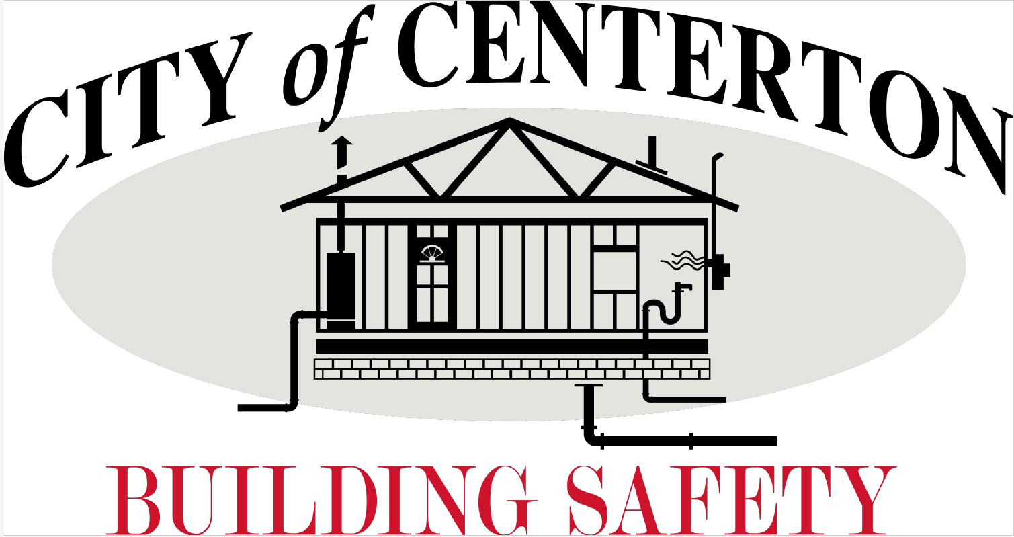
Career Opportunity
The Building & Safety Dept. has an immediate opening for a
Building Permit Clerk
.
Permit Clerk is an entry-level position responsible for issuing permits, scheduling, and posting inspections. The position issues building, electrical, mechanical, and plumbing permits on a daily basis. Has daily contact with the public and responds to requests or inquiries regarding permits. May receive phone calls and determine the nature of the business and direct phone calls or visitors to appropriate destination.
*** Applicant must be capable of learning/using BSA software proficiently as well as Microsoft systems such as email, excel, word etc.***

Great benefits include Health insurance & APERS retirement plan.

OPEN UNTIL POSITION FILLED
How to Apply!
contact Human Resources for a full job description
careers@centertonar.us or 479-795-2750 ext. 104
City of Centerton is an equal opportunity employer

